

**Future Conferences in 2016**

SPCHNA – Swarthmore University – 5/18

ACHA – San Francisco, California – 5/31-6/4

MCHNA – Delaware Valley University – 6/8-6/10

MACHA – Annapolis, Maryland – 10/6-10/7

**Spring 2016**

Happy spring!

Wow! Here we are halfway through the semester!

Thank you to Connie Murphy and all the staff at Penn who hosted a wonderful program in January. Besides the informative program (and the healthy yoga we did in between sessions) the best part of the day was seeing so many participants from various colleges represented. New members are the life of an organization and I felt the energy in the room. The sharing of information between each other across the room and in circles over lunch and at the tables speaks to the professional collegiality of SPCHNA.

Gratefully, it has been a semi -quiet flu season for most (Ursinus, unfortunately had the norovirus and all our sympathy!) But then we had to deal with the Zika virus and our traveling students. The life of the college health nurse is constantly changing and challenging!

Have a good end to the school year. Hope to see you at the spring SPCHNA conference to be hosted by Swarthmore College on May 18, 2016. Please visit the SPCHNA website for Brochure and Registration Information: http://www.spchna.org/

Mary Agnes

President SPCHNA

Also Congratulations to Chris Rooney, recipient of the Wiener Mentoring award through ACHA!

Future Conferences:

SPCHNA – University of the Arts – 5/20

ACHA – Orlando, Florida – 5/26-5/30

MCHNA – Shippensburg University – 6/3-6/5

MACHA – Atlantic City, NJ – 10/22-10/23

Spring 2016

Newsletter

October 29, 2013

Website: [www.spchna.org](http://www.spchna.org) President: Mary Agnes Ostick 610-519-6076 [maryagnes.ostick@villanova.edu](mailto:maryagnes.ostick@villanova.edu) ; Vice President: Susan Fitzgerald 610-902-8400 [sfitzgerald@cabrini.edu](mailto:sfitzgerald@cabrini.edu); Secretary: Joanne Ocasio 717-872-3250 [joanne.ocasio@millersville.edu](mailto:joanne.ocasio@millersville.edu); Treasurer: Cheryl Donnelly, 610-328-8058 cdonnel1@swarthmore.edu; Member at Large: Robyn Spragins 610-430-4189

Southeastern Pennsylvania College Health Nurses Association, Inc.

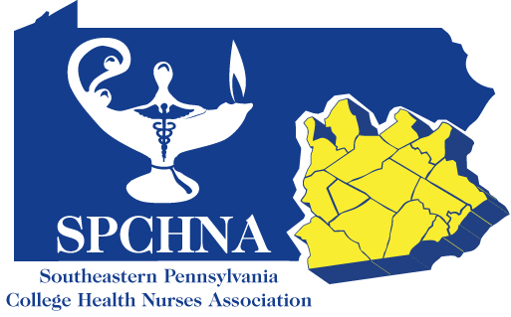

Log and Dialogue

*Renew your membership in SPCHNA by Jan 31, 2014 at www.spchna.org*