Directions to Holy Family University:
9801 Frankford Ave, Philadelphia, PA 19114 Parking:

Planning Committee
Kathy Pichel- McGovern, CRNP
Tracy Boyle, DNP, FNP-BC, PMHNP
Olisa Okoh, BSN RN
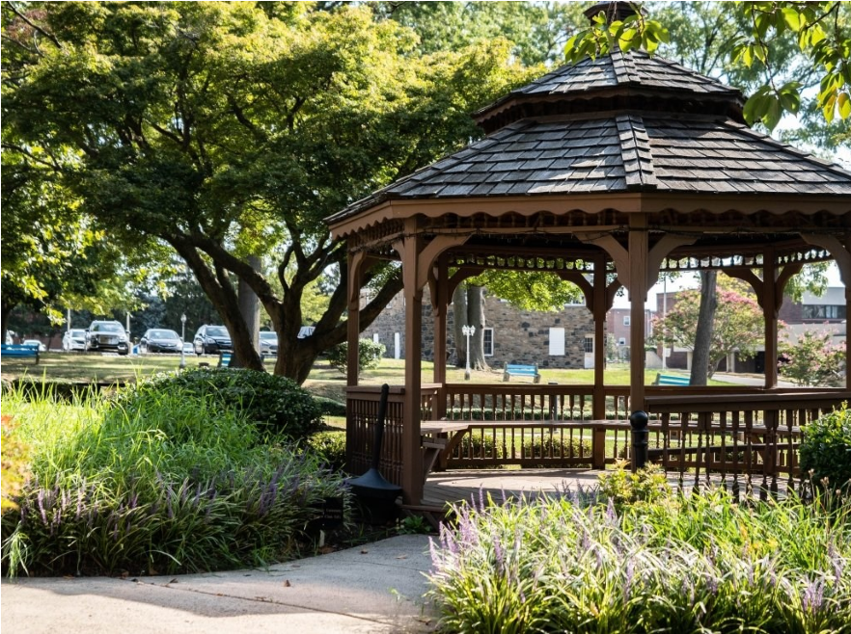
DISCLOSURES
This activity has been submitted to the Pennsylvania State Nurses Association for approval toward con tact hours. The Pennsylvania State Nurses Association is accredited as an approver of nursing continuing professional development by the American Nurses Credentialing Center’s Commission on Accreditation.

No member of the planning committee or faculty have disclosed a conflict of interest.

Attendance at sessions and completion of evaluation for educational sessions is required to receive continuing nursing education.

For more information regarding education hours, please contact Olisa Okoh at olisa.okoh@gmail.com

Updates in
College Health
Holy Family University
January 4, 2023
ETC Auditorium

9801 Frankford Ave, Philadelphia, PA 19114
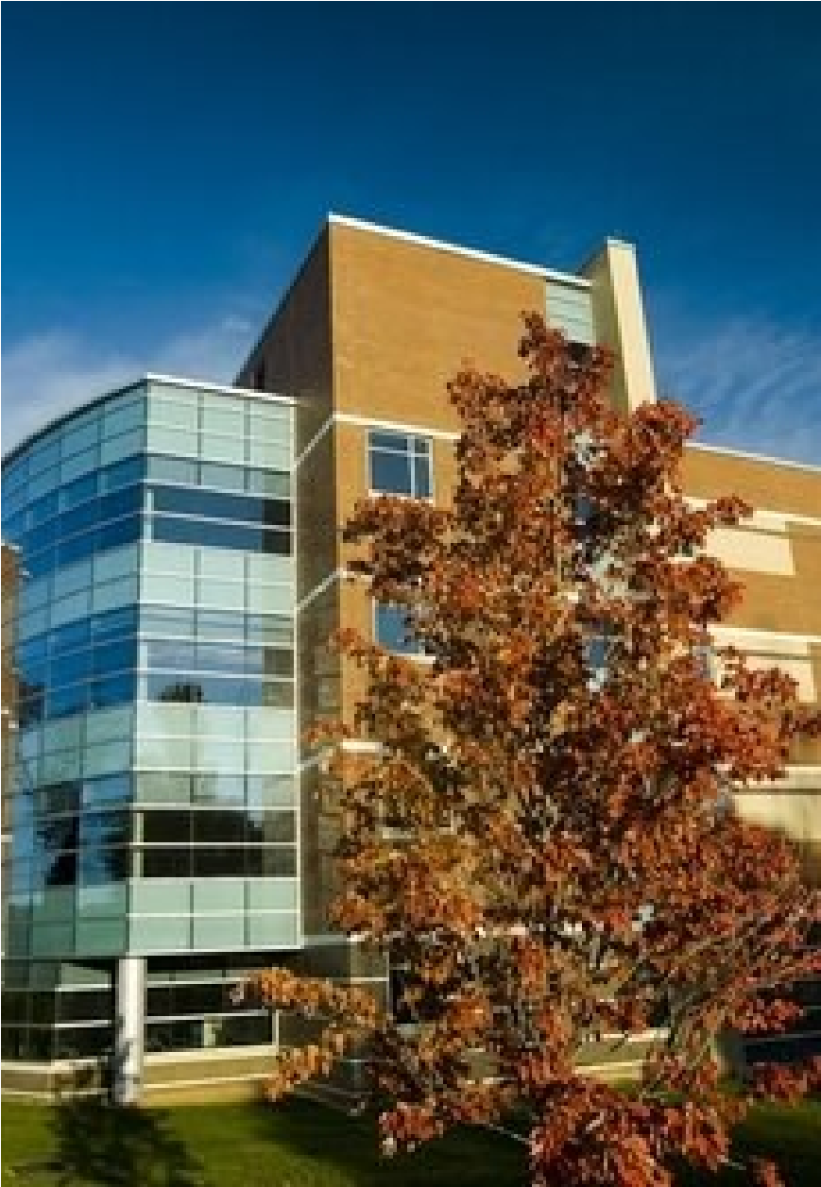

Fees and Registration

Active member—$35
(w/ updated membership)
Late registration/active member—$45
Non-member—$60
Late registration/non-member—$70
Registration closes on 12/09/22
Late registration closes on 12/21/2022

Register at www.spchna.org

The purpose of this conference is to increase participants’ knowledge and therefore improve practices regarding migrant and refugee health, restrictive eating disorders, LGBTQ health care, Monkey Pox/COVID, Mental health after COVID, and tickborne illnesses.

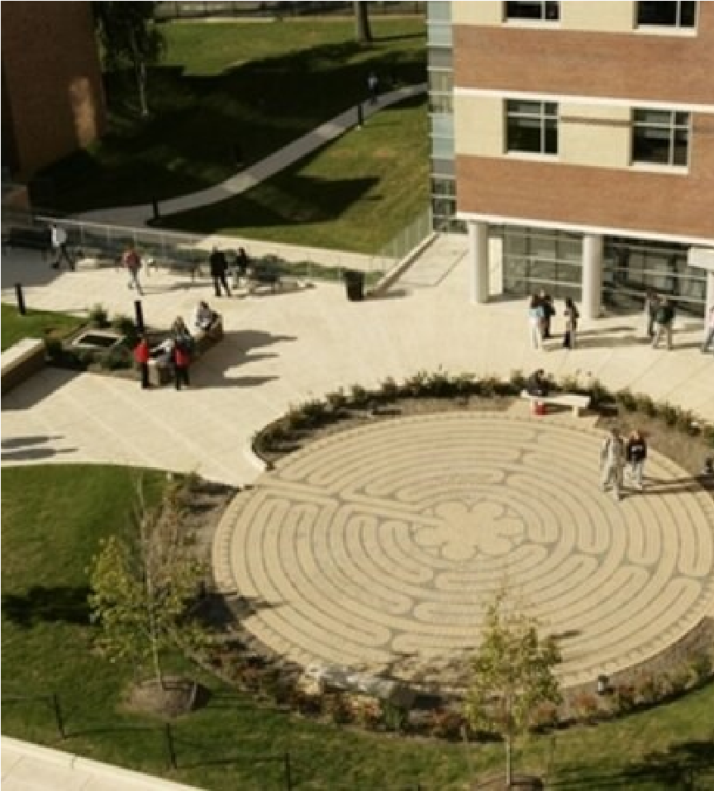
SPCHNA Winter 2023 Conference Agenda

8:00 AM – 8:30 AM
Registration and Vendors Breakfast sponsored by Gallagher Student Health Insurance

8:30 AM – 9:00 AM - Welcome and Introduction from President and Board

9:00AM – 10:00 AM
LGBTQ Sexual Health Care
Dane Menkin, CRNP
Bryn Mawr Family Practice

10:00 AM – 10:10 AM - Break

10:10 AM – 11:00 AM
Migrant and Refugee Health
Kathy McGovern, NP

11:00 AM – 11:30 AM
Monkeypox/COVID Update
Shara Epstein, MD

11:30 AM - 12:00 PM- SPCHNA Business Meeting

12:00 PM - 1:00 PM - Lunch sponsored by RCMD Student Health Insurance

1:00 PM – 1:50 PM
What is ARFID?
Natalie Zaparzynski, MA, RD, LDN
Haverford College

1:50-2:00 PM – Break

2:00 PM – 3:30 PM
Tickborne Illness
Emily Kehoe, MPH

3:30 PM – 4:15 PM
Anxiety and Depression Post COVID
Holy Family University

4:15 PM – 4:30 PM
Wrap-up and Departure

THANK YOU!

